Tacita Project Setup Guide
Repository link: https://github.com/Nicholas-Kai-Yuan/TacitaProject
1. What You Need First
- A GitHub account
- Git installed on your computer.
- Node.js LTS installed
- VS Code installed.
2. Accept the GitHub Invite
1. Open the GitHub invitation link or check your email for the repository invite.
2. Accept the invitation.
3. Open the repository page: https://github.com/Nicholas-Kai-Yuan/TacitaProject
3. Clone the Project
Open PowerShell or the VS Code terminal and go to the folder where you want to store the project.
cd "D:\School\Tacita Project\Coding"
Clone the GitHub repository:
git clone https://github.com/Nicholas-Kai-Yuan/TacitaProject.git
Go into the project folder:
cd TacitaProject
4. Open the Project in VS Code
code .
If the code command is not available, open VS Code manually, then choose File > Open Folder and select the TacitaProject folder.
5. Install Dependencies
In the VS Code terminal, run:
npm.cmd install
Use npm.cmd on Windows because PowerShell may block npm.ps1 scripts.
6. Create the Environment File
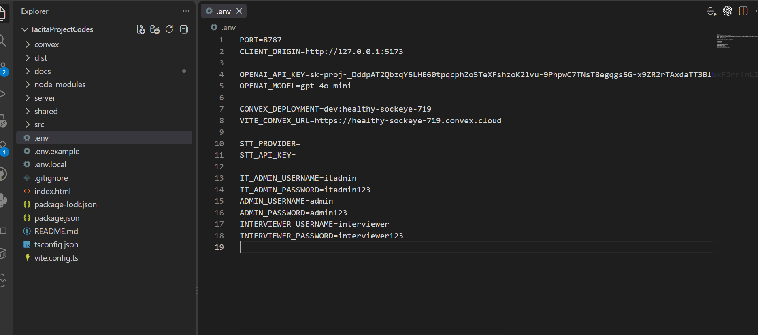
Shld have a .env file that contains these:
PORT=8787
CLIENT_ORIGIN=http://127.0.0.1:5173

OPENAI_API_KEY=YOUR_OPENAI_API_KEY
OPENAI_MODEL=gpt-4o-mini

CONVEX_DEPLOYMENT=dev:healthy-sockeye-719
VITE_CONVEX_URL=https://healthy-sockeye-719.convex.cloud
IT_ADMIN_USERNAME=itadmin
IT_ADMIN_PASSWORD=itadmin123
ADMIN_USERNAME=admin
ADMIN_PASSWORD=admin123
INTERVIEWER_USERNAME=interviewer
INTERVIEWER_PASSWORD=interviewer123
7. Convex Hosted Database
The database can be accessed through the same tacita email created
Email: tacitaproject0@gmail.com
https://dashboard.convex.dev/t/tacitaproject0/tacita-project/healthy-sockeye-719/data?table=interviewSettings

In terminal run:
npm.cmd run convex:dev
Follow the Convex prompts, then copy the generated CONVEX_DEPLOYMENT and VITE_CONVEX_URL values into .env.
Convex dashboard: https://dashboard.convex.dev
8. Launch the Project
Start the frontend and backend together:
npm.cmd run dev
Wait until the terminal shows the Vite frontend and TACITA API running.
Open this URL in your browser:
http://127.0.0.1:5173
9. Default Login Accounts Credentials
These accounts are bootstrapped into Convex if they do not already exist:
IT Admin: itadmin / itadmin123
Admin: admin / admin123
Interviewer: interviewer / interviewer123
The IT Admin can create real Admin and Interviewer accounts from inside the app.

